**The Dizzy Charger:**

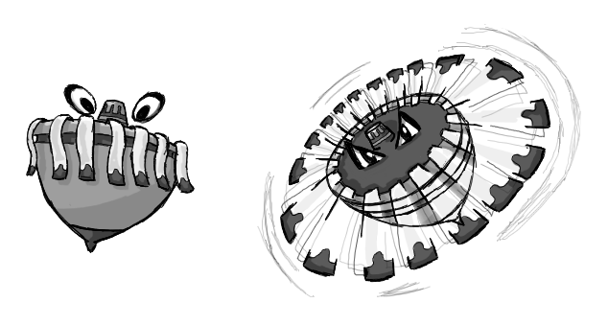

**Brief Synopsis**

The Dizzy Charger is an exceptionally weak enemy that appears in groups, its design is based off a spinning top with ribbons attached to the sides. When the player character is out of range it will rock back and forth on the spot not moving. Once the player comes into range it will begin spinning followed by leaning in the direction of the player and moving towards the position the player was in once they had first come within the range. The effective weapon to use against these enemies would be the **Scythe**, this is due to how little health they have and how they appear in large groups.

**AI**

The Pathfinding this enemy will simple as it will only move straight towards the player and not try to avoid obstacles. If this enemy collides with an obstacle before it hits the player, it will die.

**Variants**

Variants of this enemy would alter their basic movements, rather than moving towards the initial position of the player, which would be used in early levels so that these enemies could be easily avoided, they could instead continuously home in on the player, slowly correcting there trajectory to correct against the players movements, these would still not avoid obstacles and would die upon hitting them. To differentiate these variants the ribbons colours will alter, making it clear both when idling and attacking which variant is which.

**Animations**

The Dizzy Charger will have two states, idle and attacking. There will be a single transition animation between these.

**Idle:**

* Rocks back and forth on the spot, no actual animations needed, (unless having the ribbons affected by gravity).

**Idle -> Attacking:**

* The model is span at an increasing rate until a max rotation speed is reached, as this is happening the ribbons straighten out like helicopter blades.

**Attacking:**

* Model is just rotated on its axis, the and tilted in the direction its moving.

**Death:**

* It will explode or something.